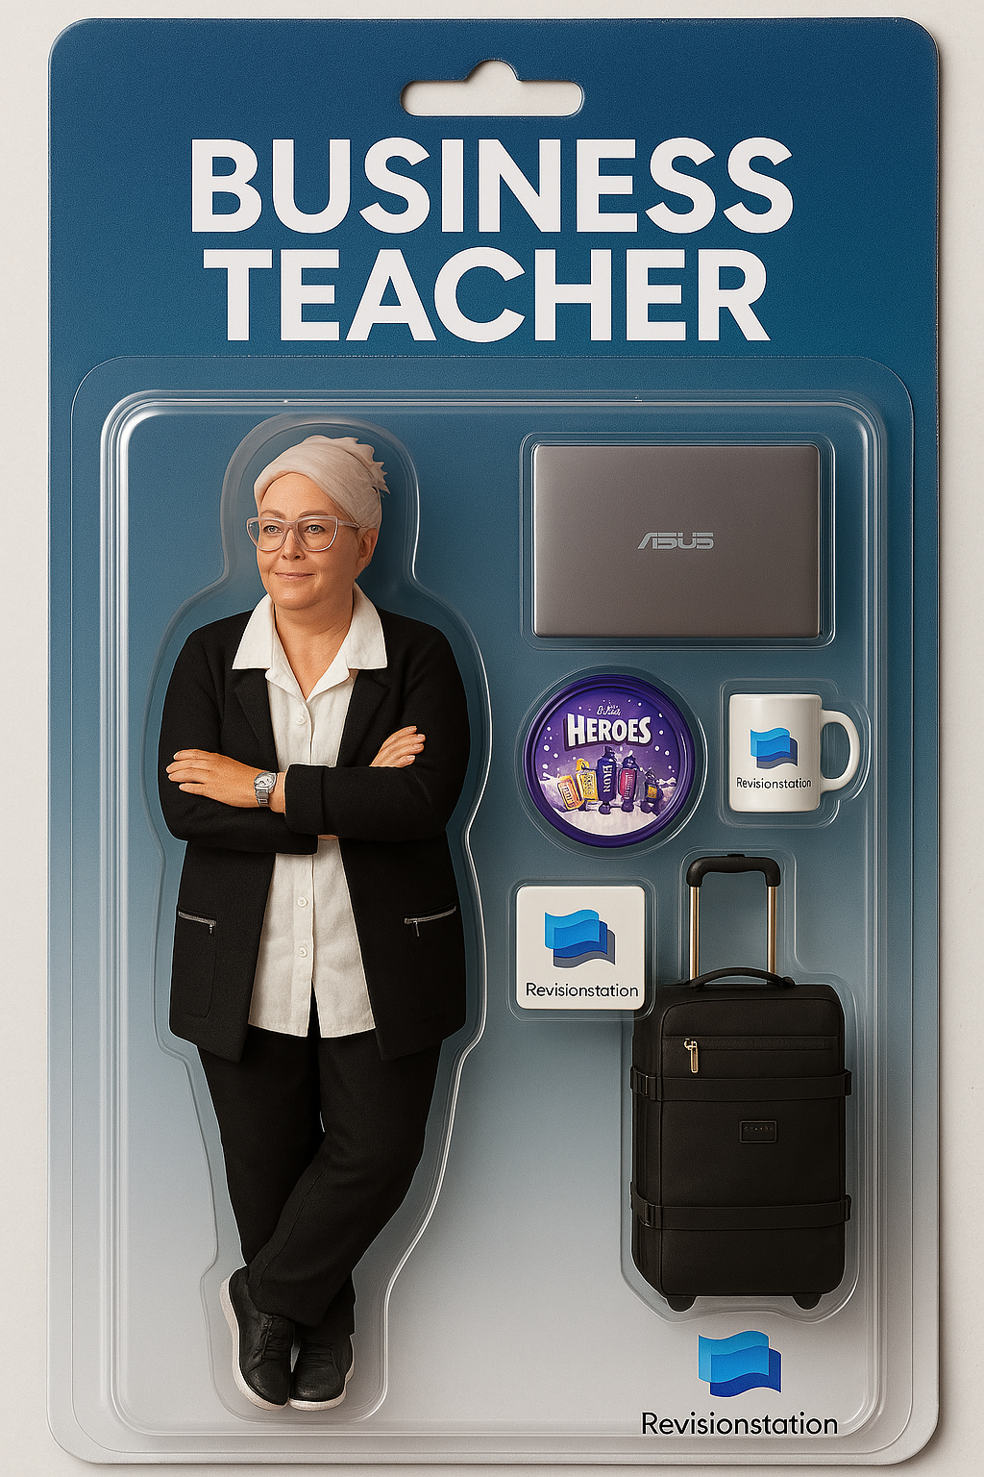

AI CHALLENGE - HOW TO MAKE YOURSELF INTO AN ACTION FIGURE ON CHAT GPT

1. **Upload a photo of yourself to Chat GPT – full length works best, but it can work with less. You can just drag and drop an image on there, even if it has a background.**
2. **Enter this prompt:**

**Draw an action figure toy of a person on this photo. The action figure should be full-figure and displayed in its original blister pack packaging. On top of the box is the name of the toy “Your name in here ” across a single line of text. In the blister pack packaging, next to the figure, show the toy’s accessories, including a put accessory 1, accessory 2. There should be a label on the corner of the box that says “Limited Edition”. This figure should look like a premium toy and everything should be inside the plastic!**

1. **Be as specific as you possibly can about your accessories. For example It could be a thin white cat with green eyes.**
2. **Add in any other logos e.g. Cadbury’s Heros logo.**
3. **Then change your prompt to get as close as possible to how you would like your action figure to look. Try changing your stance e.g. legs crossed. Try changing how realistic the figure is.**